Yale redesign: <https://www.medrxiv.org/content/10.1101/2020.04.03.20052217v1.full.pdf>

Updates on Design:

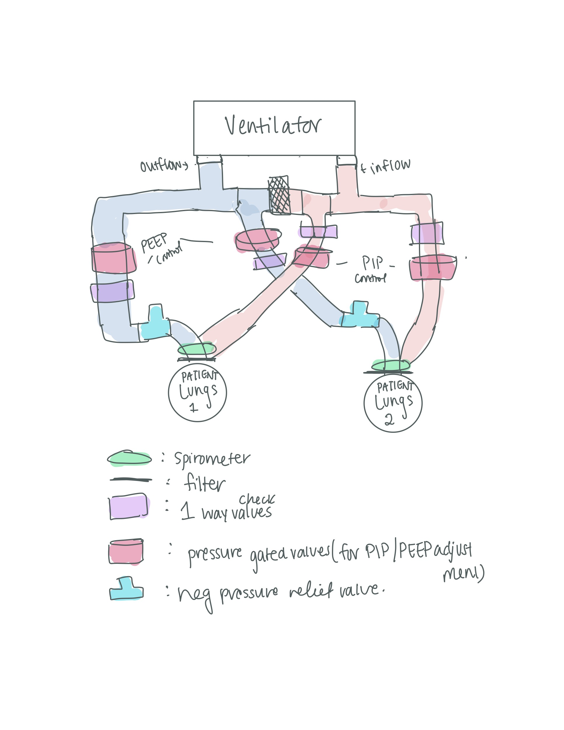

Notes:

* Improve on Co2 ? Integrate but not important
* Alarm System - pressure sensors + accurately measure individual tidal volumes

Action Items:

* **DIY Stepper/Servo** - Hannah and Jacob and Alaukik and Karan
  + Figure out how to test - Karan
  + Figure out how to regulate pressure - Jacob and Emily
    - <https://physics.stackexchange.com/questions/95620/how-does-pressure-of-a-fluid-change-with-area-according-to-the-continuity-equat>
  + Materials + Design/3d printing - Hannah, Alaukik
  + Flowchart for pressure valve- All
* **Spirometer** - Abhishek and Karan
  + <https://www.instructables.com/id/Low-Cost-Spirometer/>
* **Flowcharts/Pseudocode for Spirometer** - Jennifer Annie
* **Alarm System** - Emily, Annie, Alaukik